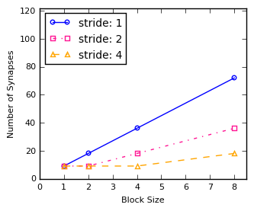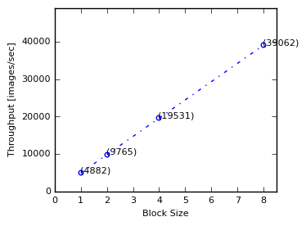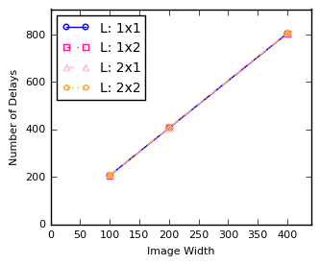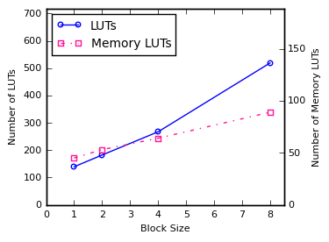

|  |  |
| --- | --- |
| CIFAR10 Simulation Result | |
| Block size(L) | Elapsed time(n sec) |
| (1,1) | 2542560 |
| (1,2) | 1559520 |
| (2,1) | 1559520 |
| (2,2) | 1068000 |